 |  |  |  |  |  |  |  |  |  | curriculum.newvisions.org/social-studies  Timothy Lent - tlent@newvisions.org  Kameelah Rasheed - krasheed@newvisions.org | 
Please Read: We encourage all teachers to modify the materials to meet the needs of their students. To create a version of this document that you can edit:  1. Make sure you are signed into a Google account when you are on the resource.  2. Go to the "File" pull down menu in the upper left hand corner and select "Make a Copy." This will give you a version of the document that you own and can modify. |  |  |  |  |  |  |  |  |  |  | 
Teacher Overview: What was the Black Death?
Go directly to student-facing materials!

 | SQ 8. What were the effects of the Crusades? | SQ 9. What was the Black Death? |  | SQ 10. Where did the Black Death originate? How and why did it spread? | 

 | Unit Essential Question(s): How did increased interconnectedness affect the post-classical world? Link to Unit
Supporting Question(s):
- What was the Black Death?
Objective(s):
- Explain what the Black Death was and what caused it.

Vocabulary
The following words are introduced or reinforced in this lesson. Reference the unit vocabulary tracker for more information. Click here for the New Visions Global History glossary.
Word/Phrase  (part of speech) | Definition
epidemic (n.) | a widespread occurrence of a disease
pandemic (adj.) | widespread over a whole country or the world
plague (n.) | a contagious bacterial disease characterized by fever, insanity, and formation of buboes, and sometimes an infection of the lungs

Formative Assessment Possible Responses
These responses represent possible answers to the formative assessment tasks in this lesson. They are not the only correct answers. Create your own list of possible responses before using this resource with students to anticipate student misconceptions and adjust your instruction.

Event: The Black Death

What was the Black Death? | A disease, epidemic
Who was affected? | ⅓ of Europe, people in Asia, Middle East, Europe, merchants
When? | 1300s
Where? | Started in China, then spread through Asia, the MIddle East and Europe
Why? | Spread by fleas who brought the disease from rats to humans, then it was spread through contact on trade routes
Combined Context Expansion Sentence | The Black Death was a disease in the 1300s that killed people in Europe, the MIddle East, and Asia. It was passed from rats to humans through fleas, then It spread through trade routes from China to the MIddle East to Europe.

NYS Social Studies Framework:
Key Idea | Conceptual Understandings | Content Specifications
9.6 SOCIAL and CULTURAL GROWTH AND CONFLICT: During the postclassical era, the growth of transregional empires and the use of trade networks influenced religions and spread disease. These cross-cultural interactions also led to conflict and demographic impacts.  (Standards: 2, 3, 4; Themes: TCC, GEO, GOV, ECO, EXCH) | 9.6b Networks of exchange facilitated the spread of disease, which affected the social, cultural, economic, and demographic development of people. | Students will map the spread of the Black Death as it was carried westward from Asia to Africa and Europe and evaluate the impact of the Black Death on these regions.

Social Studies Practices
NYS Social Studies Practices | New Visions Student Social Studies Practices
Chronological Reasoning and Causation (B1) |   Connect Cause and Effect Predict

NYS Common Core Learning Standards
Reading | Writing | Speaking and Listening
Craft and Structure:  CCSS.ELA-LITERACY.RH.9-10.4: Determine the meaning of words and phrases as they are used in a text, including vocabulary describing political, social, or economic aspects of history/social science. | Text Types & Purposes:  CCSS.ELA-LITERACY.WHST.9-10.1: Write arguments focused on discipline-specific content. | Comprehension and Collaboration:  CCSS.ELA-LITERACY.SL.9-10.1: Initiate and participate effectively in a range of collaborative discussions (one-on-one, in groups, and teacher-led) with diverse partners on grades 9-10 topics, texts, and issues, building on others' ideas and expressing their own clearly and persuasively.

Associated Classroom Posters
Student Social Studies Practices Poster

Objective: | What was the Black Death?  - Explain what the Black Death was and what caused it.

  Predict | Introduction  ➡ Directions: Examine the image and description below, then respond the prompts.

  Imagine that over the course of the last four years a strange disease killed half of the people in the United States. The mysterious illness caused those inflicted to cough up blood and pus, and blood-filled growths to develop on their bodies. The disease spread easily from person to person and though doctors gave a lot of advice, nothing worked to stop it. | 1. How would people react to this disease?  2. Write down what effects a disease like this might have on our country and the people in it in the chart below.  Short Term Effects on the United States Long Term Effects on the United States
What was the Black Plague?

Black Death Vocabulary
Epidemic (n.)- a widespread occurrence of a disease | Pandemic (adj.)- widespread over a whole country or the world | Plague- (n.) a contagious bacterial disease characterized by fever, insanity, and formation of buboes, and sometimes an infection of the lungs | Yersinia Pestis- (n.) the bacteria that causes plague | Buboes- (n.) swollen lymph nodes in the armpit or groin

The Black Death, also known as the Black Plague, was a devastating epidemic that struck large portions of Asia, the Middle East, and Europe in the 14th century (1300s). In Europe, it killed between ⅓ and ⅔ of the population, depending on the region. In total around the world, at least 75 million people were killed by the disease in the mid 1300s.  Most scientists now believe that the Black Death was an outbreak of bubonic plague, which is a disease caused by the bacterium Yersinia pestis which lives in rodents like rats. Rats, which were common in Medieval cities, often had fleas on them. The fleas bit the rats, then jumped onto humans and bit them, which spread the disease to humans. Once the disease was in a person it was spread from person to person through body fluid and coughing.  This passage was adapted by New Visions from the Black Death on New World Encyclopedia which is published under the CC-BY-SA 3.0 license. | 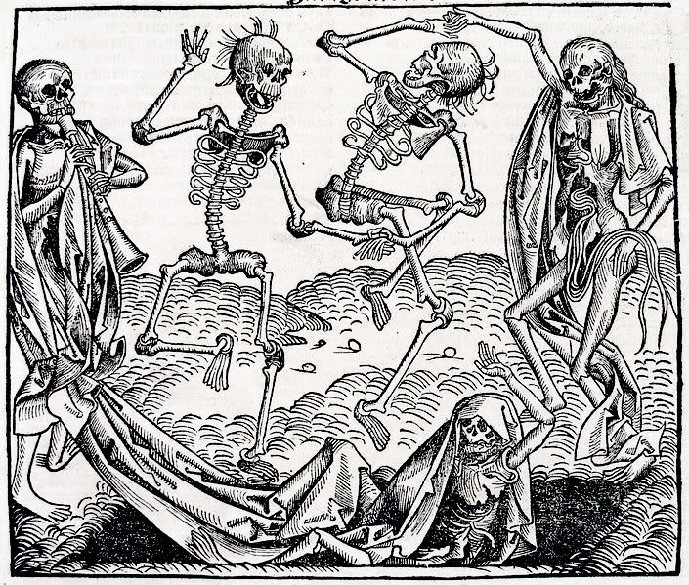  Created in 1493, this image was inspired by the Black Death and depicts the Dance of Death, which was a common theme in Medieval art because of the fear of the plague.  Image is courtesy of Wikimedia Commons and is public domain.
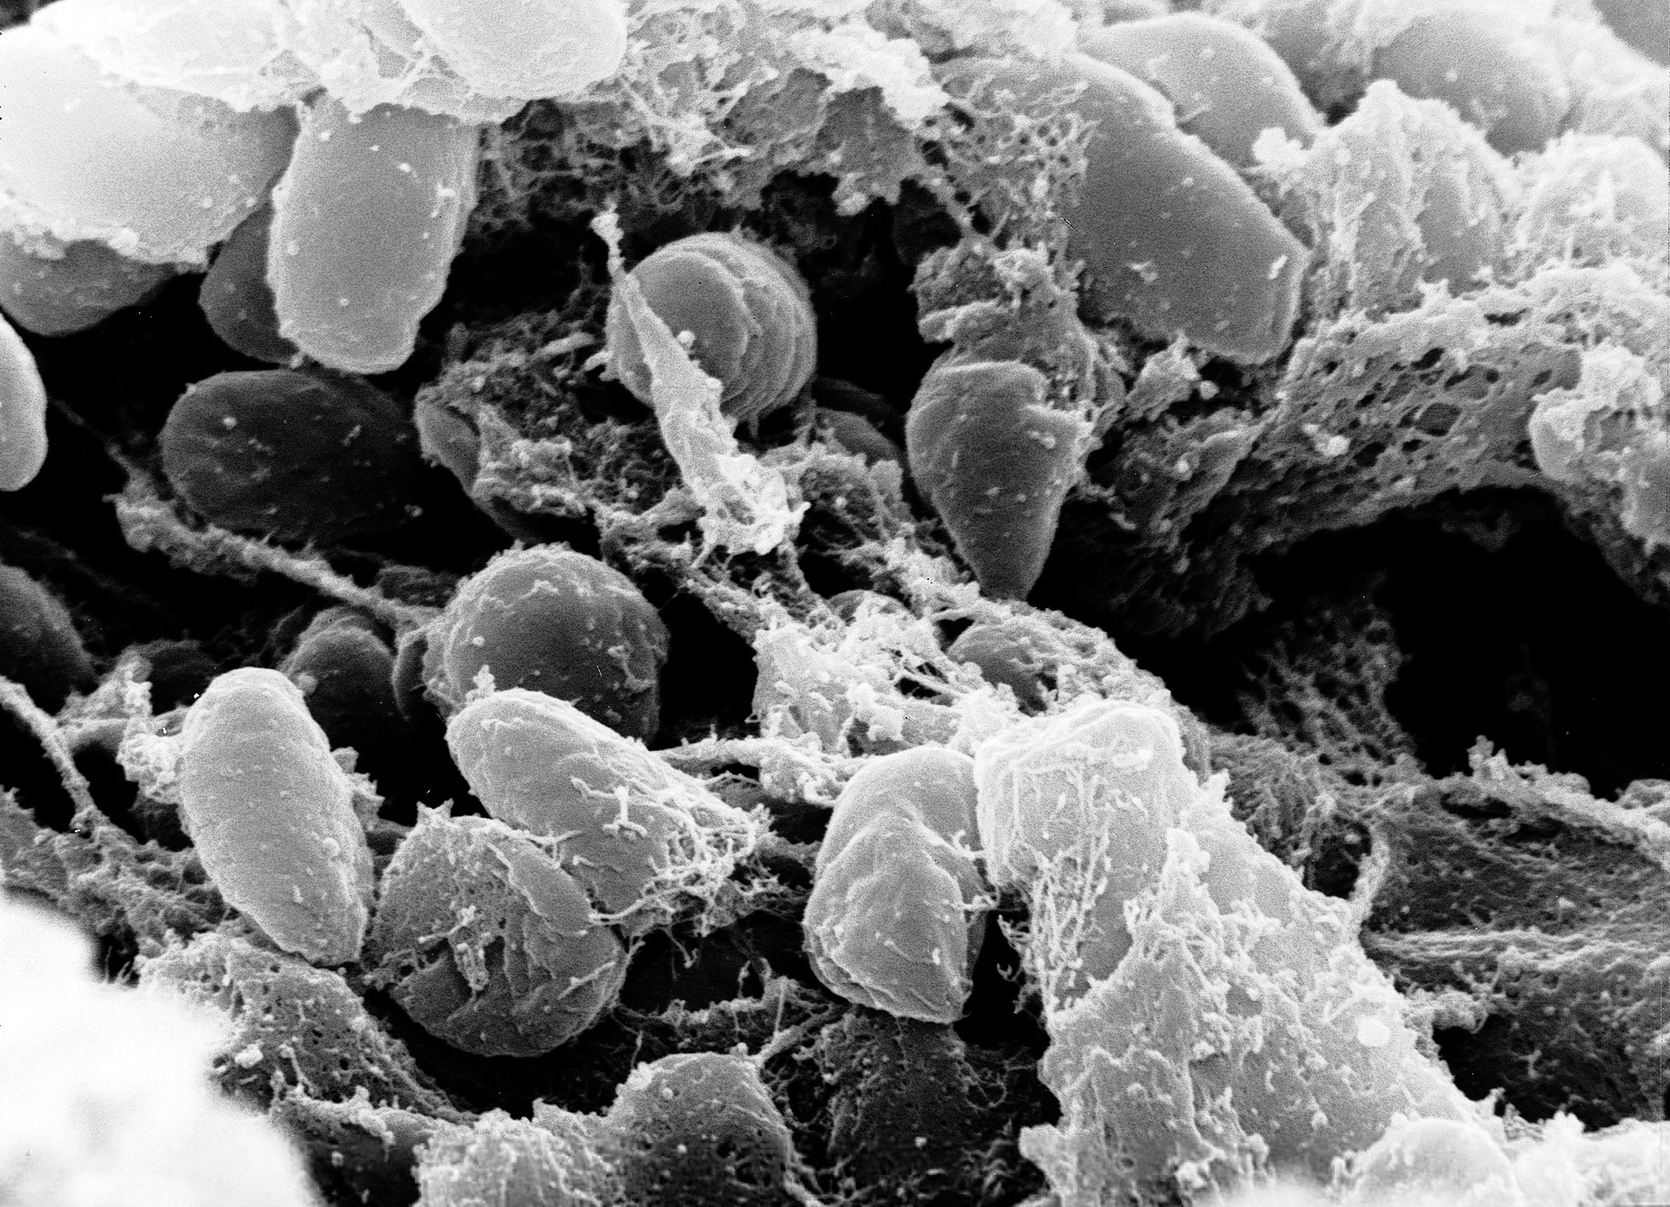
Rat contracts the bacterium Yersinia Pestis
Flea jumps on rat and bites it and has rat blood in its mouth.
Flea jumps on human and bites, mixing rat and human blood and giving human Yersinia Pestis.
Rat image is published on Public Domain Pictures under a CC BY license; Bacteria image is courtesy of Wikimedia Commons and is public domain; Flea image by Clker-Free-Vector-Images is published on thePixabay under a CC BY license; Human image is courtesy of Wikimedia Commons and is public domain.

Connect Cause and Effect |   “What was the Black Death? What were the Symptoms” from ClickView (transcript), Bubonic Plague from the BBC’s “Filthy Cities” (43:38-51:00), Coroner’s Report: Plague  ➡ Directions: Watch the clips on the Black Death linked above, then answer the questions below.

1. According the video(s) and above, what was the Black Death? | 2. What caused the Black Death? | 3. Why did the Black Death spread so far and kill so many people?

FA | SQ 9: What was the Black Death?  ➡ Directions: Using evidence from the documents above, respond to the task below in the space provided.
Connect Cause and Effect | Task 1: Describe the Black Death using the context expansion template below.  Example: Fall of the Roman Empire  Who? Roman Empire  When? 476 CE  Where? Europe and North Africa  How?/Why? political turmoil, invasions, introduction of Christianity  Combined Context Expansion Sentence 1 In 476 CE, the Roman Empire which stretched across Europe and North Africa, collapsed because of political turmoil, invasions, and tensions caused by the introduction of Christianity. Writing Strategies Used: Prepositional phrase (In 476 CE) Conjunctions (because, and)  Combined Context Expansion Sentence 2 The Roman Empire, an expansive state that stretched across Europe and North Africa, collapsed in 476 CE due to political turmoil, invasions, and tensions caused by the introduction of Christianity. Writing Strategies Used: Appositives (...,an expansive state that stretched across Europe and North Africa,...) Conjunctions (due to, and)  Content and Vocabulary Checklist  Use the checklist below to assess the use of important content and vocabulary in the unit.  Self Yes/No Teacher Yes/No Did you use the content and vocabulary below in your response?  disease  plague  trade  Event: The Black Death  What was the Black Death?  Who was affected?  When?  Where?  Why?  Combined Context Expansion  Sentence  Formative Assessment Discussion  Turn and Talk Turn to a partner and share your response with them, then ask for them to share their response with you. If you would like to, add or change information in your response. Answer the question- What was similar and what was different about our responses? Why?

